**Documentation for Positioning Heatmap**

1. Do not attempt to put heatmap into the Tab popup window. Doing so will result in the black color error as shown in Fig. 1.

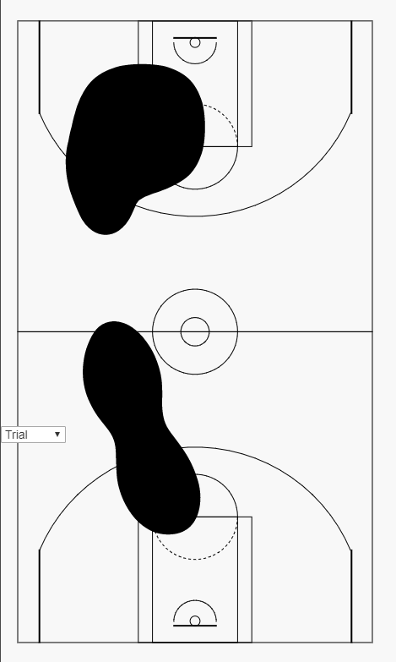

*Fig.1: Heatmap showing black color only.*

1. The heatmap draws data from a csv file which is written when the user clicks into a match and a recording. Fig. 2 shows the part of the code that reads the data from the database and writes it on to a csv file. This portion of the code can be found in ***replay.html***.

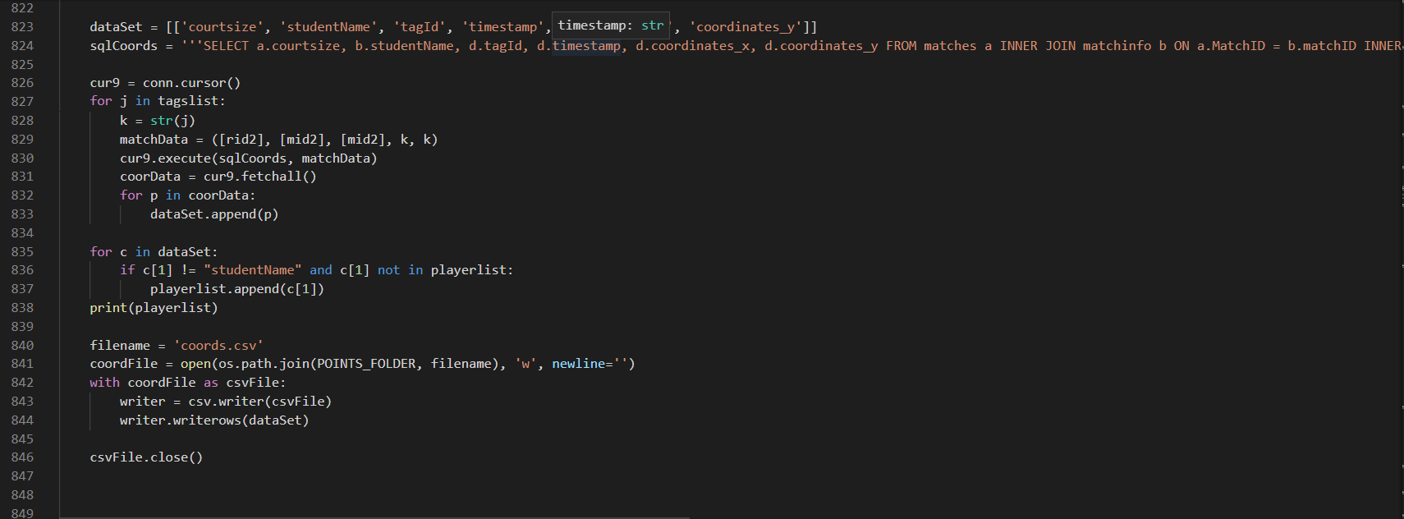

*Fig. 2: Part of the code that retrieves data from database and writes data onto csv file*

1. The code that draws the basketball court of the positioning heatmap is found in Court.js (*SPORTA_caa111454H Feb 19\fyp\static\bbCourtHeat*). In order to draw half court, please refer to Court1.js that is found in the same folder. The portion of code highlighted in Fig. 3 should be commented out if half court is to be drawn. This code can be found in ***heatmap.html***.

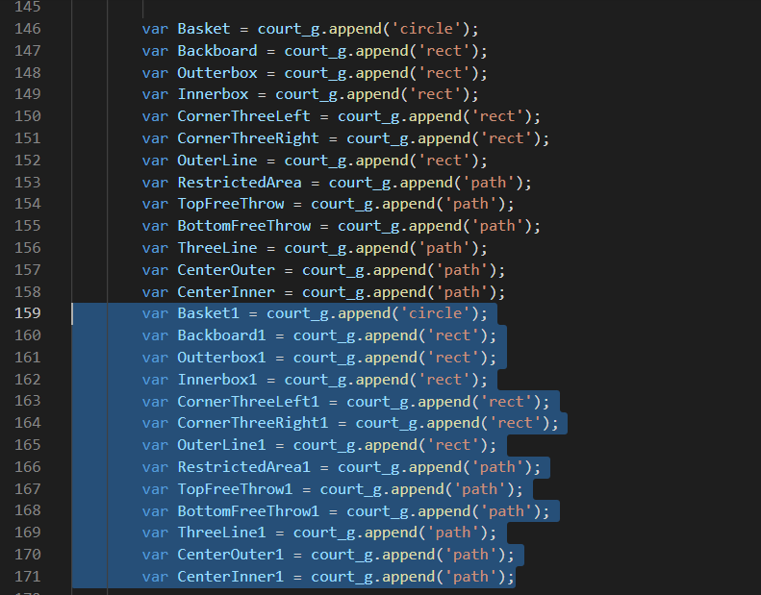

*Fig. 3: Code that needs to be commented out if drawing half court only.*

1. Important thing to note when drawing heatmap: As at the time of writing this document, there is no sure way of ensuring the heatmap is accurately ploted. Fig. 4 shows the part of the code that needs to be edited and tried out. Two very important ranges that will require further trial and error are shot_xScale and shot_yScale. court_xScale and court_yScale are worth exploring as well. This portion of the code can be found in ***heatmap.html***.

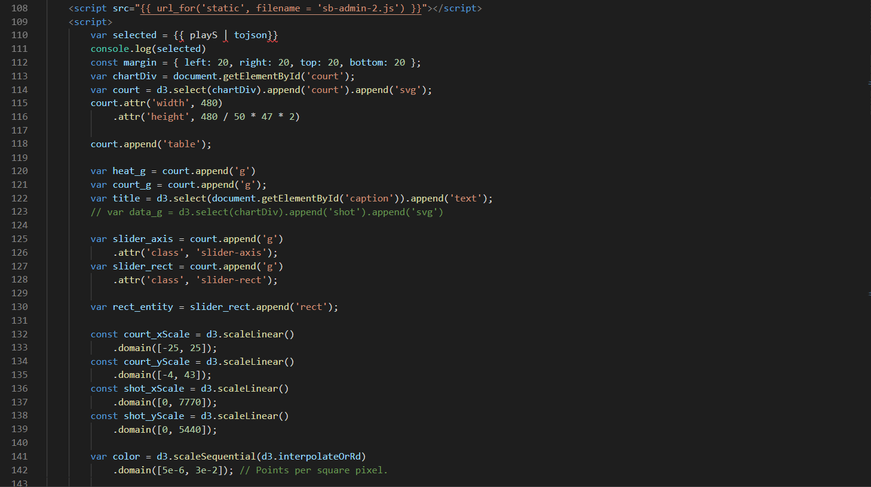

*Fig. 4: Code that sets the range values of the heatmap as well as the basketball court position.*

1. The following portion of code (Fig. 5 & Fig. 6) reads the data from a csv file and draws the contour before applying colors to the heatmap. This portion of the code can be found in HeatMap.js.

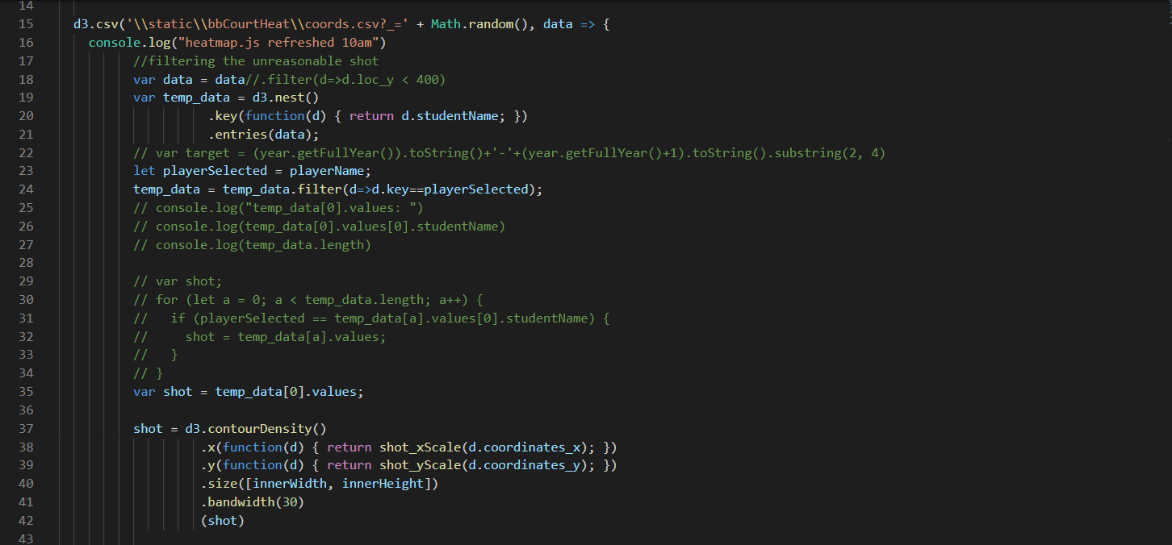

*Fig. 5: Portion of code that reads data from csv file and draw contours of heatmap.*

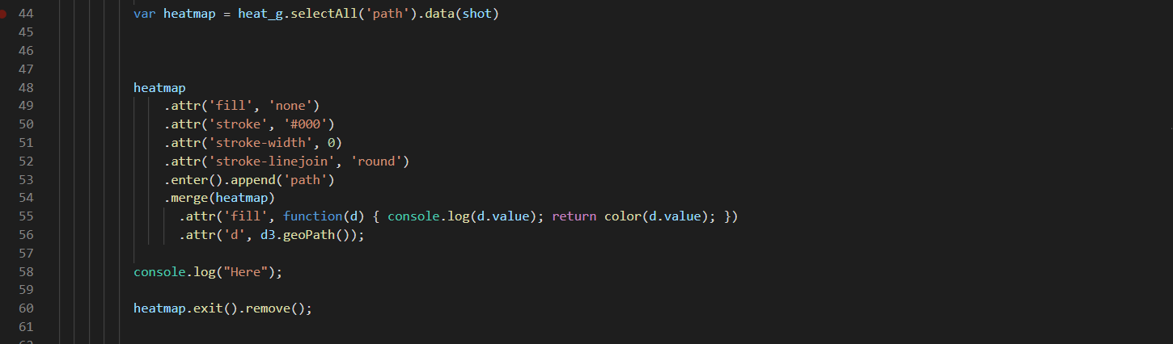

*Fig. 6: Portion of code that assigns colors to the heatmap.*